MRE_SCALE_DIM_L2

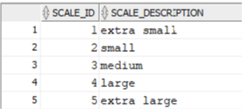

MRE_FEATURE_CAT_DIM_L2

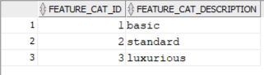

MRE_PROPERTY_FEATURE_BRIDGE_L2

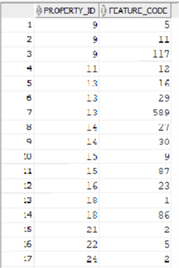

MRE_FEATURE_DIM_L2

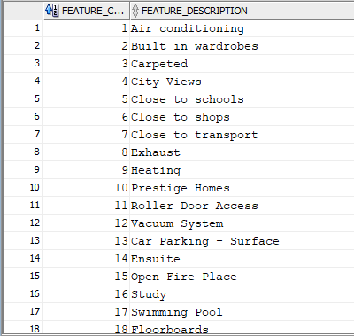

MRE_PROPERTY_TYPE_DIM_L2

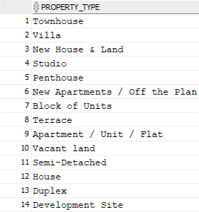

MRE_ADDRESS_DIM_L2

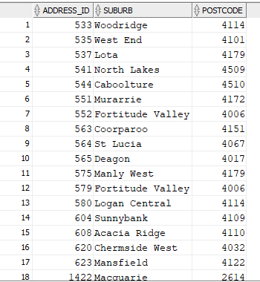

MRE_POSTCODE_DIM_L2

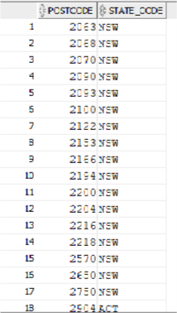

MRE_STATE_DIM_L2

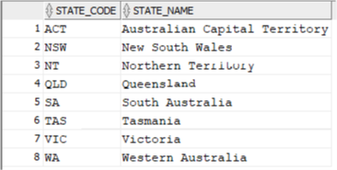

MRE_ADVERTISEMENT_DIM_L2

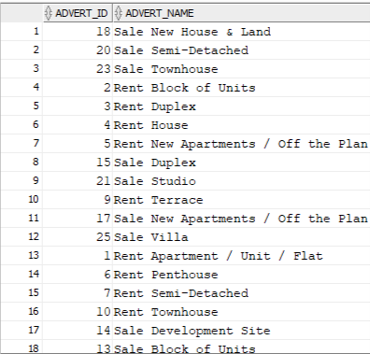

MRE_PERSON_DIM_L2

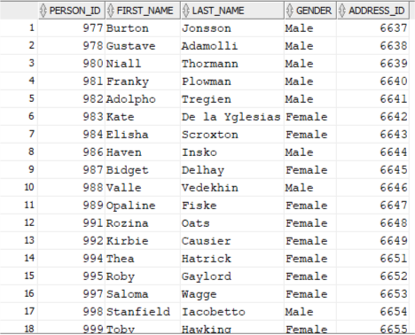

MRE_AGENT_OFFICE_DIM_L2

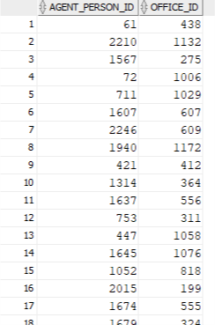

MRE_OFFICE_DIM_L2

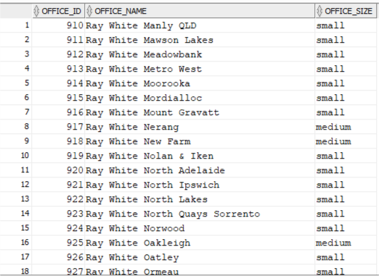

MRE_BUDGET_DIM_L2

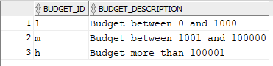

MRE_RENTAL_PERIOD_DIM_L2

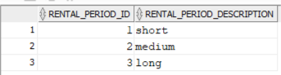

MRE_WISHLIST_DIM_L2

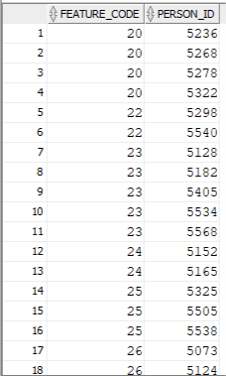

MRE_RENT_PRICE_DIM_L2

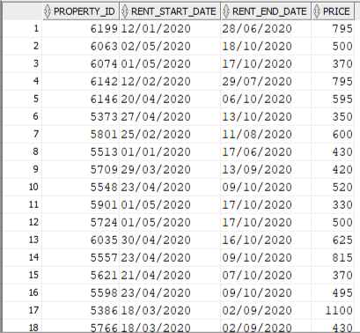

MRE_TIME_DIM_L2

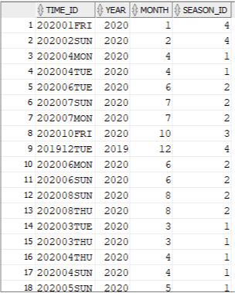

MRE_SEASON_DIM_L2

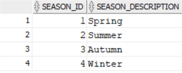

MRE_AGENT_FACT_L2

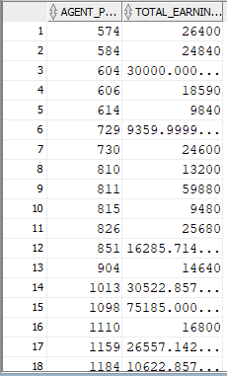

MRE_CLIENT_FACT_L2

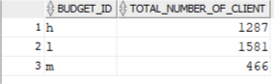

MRE_RENT_FACT_L2

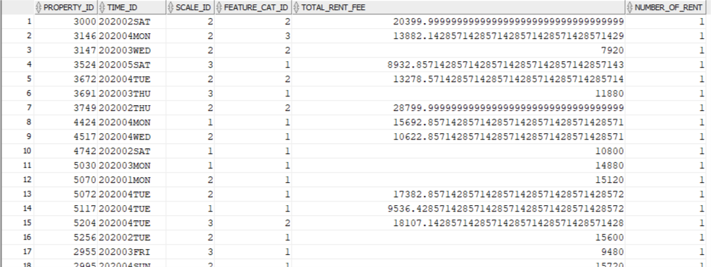

MRE_VISIT_FACT_L2

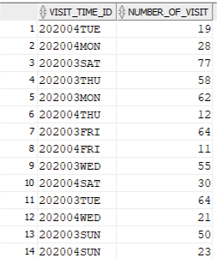

MRE_SALE_FACT_L2

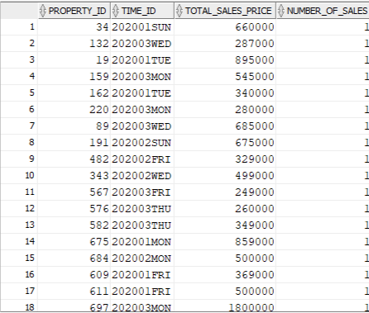

MRE_ADVERT_FACT_L2

